**Present and future species distribution of pearly heath (*Coenonympha arcania)***

**Name: Megan Verhagen student number: 1539183**

**Introduction**

The pearly heath or *Coenonympha arcania* is a butterfly that belongs to the Nymphalidae family. *C.arcania* fly in one generation from May to August and the larvae feed on grasses. This species occurs in warm, dry and open grasslands near forest edges. *C.arcania* is a species with low mobility. It can be found from Portugal to the Ural and from South-Sweden to Northern-Spain, South-Italy and Northern- Greece (Fig.1). On an European scale *C.arcania* is not endangered and occurrences are in general stable.

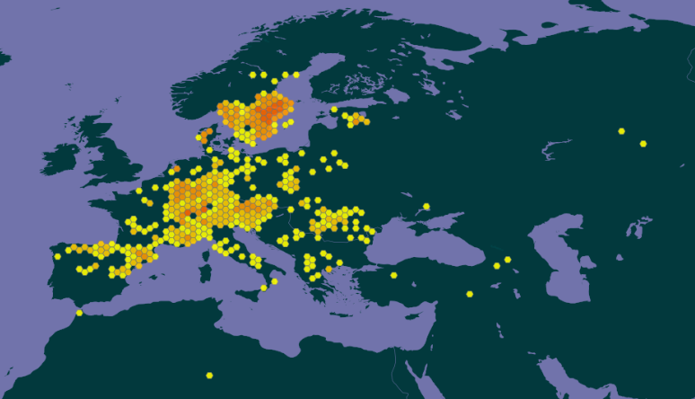

Figure 1: species distribution of *C.arcania* in Europe*.*

**Methodology**

In MAXENT ‘create response curves’ was selected. Nothing was changed in the settings since the default setting was correct. ‘Remove duplicate presence records’ was already selected, the ‘Random test percentage’ was already set to zero and the ‘Max number of background points’ was already set to 10,000.

Four variables were selected of which two were temperature related and the other two were moisture related. Bio1, which is the annual mean temperature, was selected because mean temperature probably has a bigger influence on species occurrence than temperature extremes. Also it seemed like a better idea to take the whole year into consideration instead of just one quarter of it since that should give less extreme measurements which are (like mentioned before) less important. Bio4, which is the temperature seasonality, was selected since the differences between the highest and lowest temperatures are more important than the data from the extreme temperatures. Environmental variables can change and species can deal with that as long as those changes are within the range of that species. A species should be able to survive extreme conditions if those conditions only last for a short amount of time, however if those extreme conditions differ a lot from each other, the chance of the condition getting outside the species range will be bigger. Therefore the difference between the annual maximum and annual minimum temperature (temperature seasonality) is more interesting to look at than the actual temperature extremes.

Bio12, which is the annual precipitation, was selected because this species prefers dry environments. Since precipitation can be very variable per month and quarter, it seemed like the best idea to look at precipitation over the course of a year. Bio15, which is the precipitation seasonality, was selected because it gives the range in which precipitation occurs over the course of a year instead of only a certain moment of the year. This has a bigger influence on the species that measurements taken over a shorter amount of time.

**Model Output**

With the model selected model two maps were created that show the present distribution and the future distribution of *C.arcania* (Fig.2). The maps show that the species will disappear from central Europe and the occurrences will decrease in other areas as well. According to the AUC value (0.838) this is a good model (Fig.3). When looking at the variable importance table (tab.1) it becomes clear that variable bio4 is driving the distribution pattern of *C.arcania*.

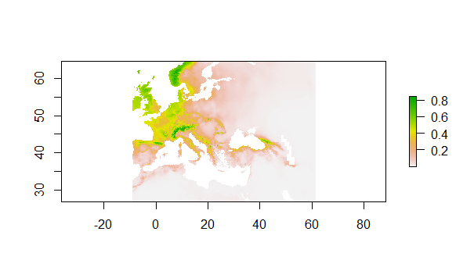

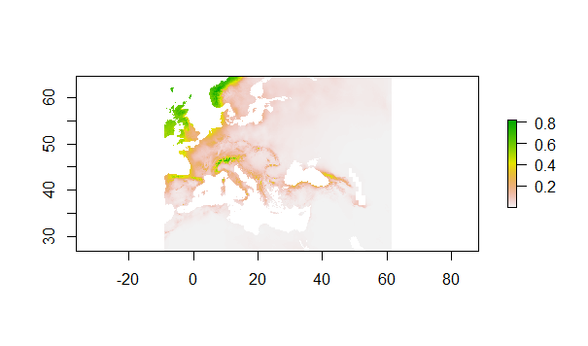

Figure 2: species distribution map for the present and the future. The first map is the map of the present distribution, the second one is the future distribution

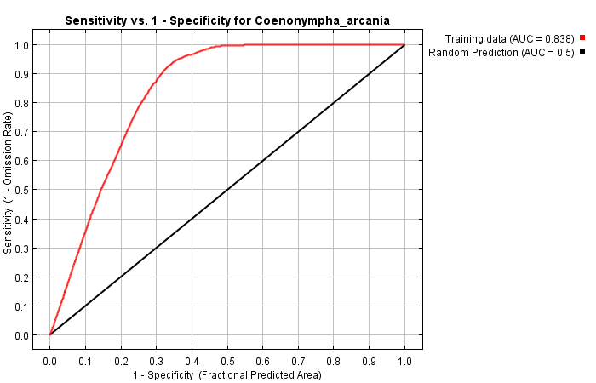

Figure 3: Area Under Curve (AUC) value of the Species Distribution Model (SDM).

Table 1: Variable importance table

|  |  |  |
| --- | --- | --- |
| Variable | Percent contribution | Permutation importance |
| Bio4 | 49.6 | 57.3 |
| Bio12 | 31.5 | 12.7 |
| Bio1 | 11.8 | 17.6 |
| Bio15 | 7.1 | 12.4 |

**Response to future scenario + biological interpretation**

The species is expected to move from central Europe to the North since its habitat in the centre of Europe will be lost for the most part while the habitats in the North remain suitable. Since *C.arcania* does not possess a lot of mobility, the chances of them moving to the North naturally are slim. If the distribution does shift to the North, it will probably be due to human influences.

This model is not very useful since the distribution data shows that there are occurrences of *C.arcania* in habitats which, according to the future distribution change map, have never been suitable for the species (Fig.4). This model is limited by the fact that it only incorporates weather data while weather phenomena are of course not the only factors which determine whether a species occurs in a certain area or not. Biotic factors play a huge role as well in the distribution of a species yet species distribution models often only include climate variables and species presence data (as is also the case with this model). Other factors like land use also have an impact on this species which is not taken into consideration in this model.

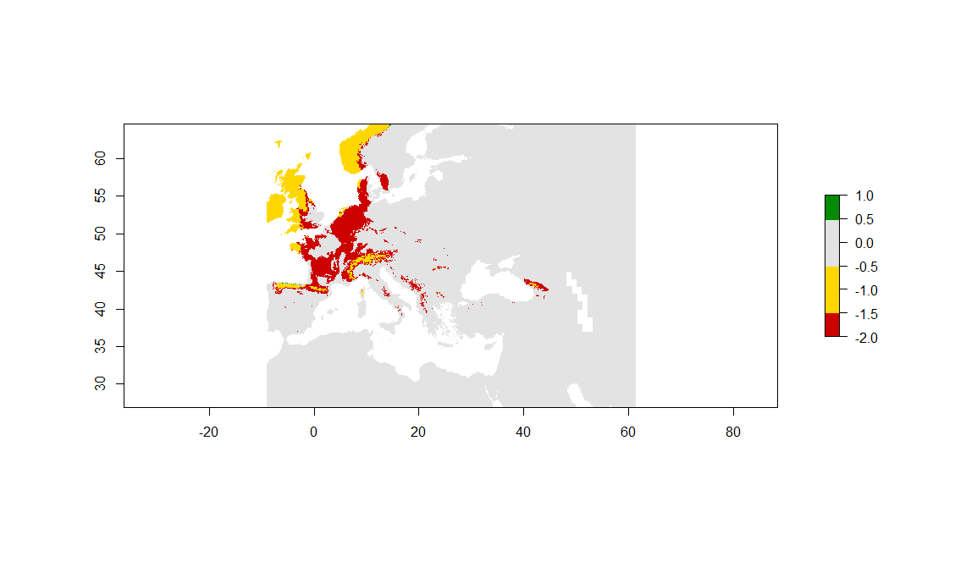

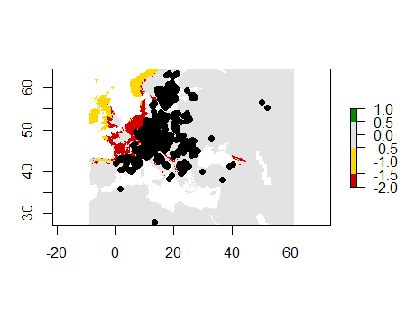

Figure 4: future distribution change map (first map is without showing occurrence data so you can better determine the status of the habitats). Green= habitat gained, grey= habitat never suitable, yellow= habitat remains suitable, red= habitat lost.